**VENDING MACHINE PROGRAM**

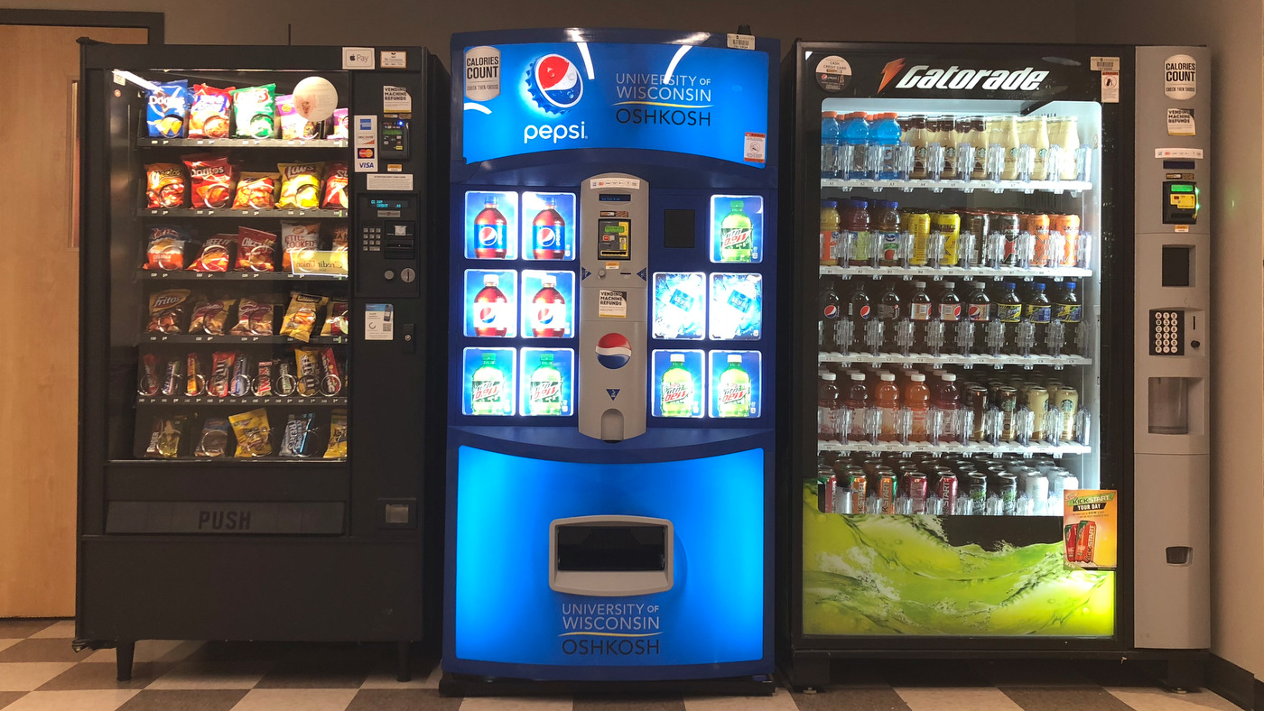

**Description:**

In this program you will write the logic for a vending machine. The vending machine will have at least 5 menu options for the user to select. The user will enter a number corresponding to the item they want or 0 to quit. When a selection is made you should print a message telling the user what was purchased, and the cost of the selected item will be added to the user’s total. The user should be prompted with the menu again. Any input that is not 0-5 should cause a “Invalid message to be printed.

When the user enters 0. The vending machine should print out the user’s total if the user bought anything. Otherwise, a message telling the user that they didn’t purchase anything should be printed. After the total has been printed, the program will prompt the user to input a float amount as payment. The input must be verified to be equal to or greater than the total. This is done using a **while** loop. If it isn’t equal or greater, continue prompting the user for more money (float numbers) to be added to their payment.

Finally, the program will calculate how many dollars, quarters, dimes, nickels, and pennies the user will get back as change. The change will be return in the least number of pieces of currency. For example, change of .10 would be returned as one dime not 10 pennies.

*INPUT:*

* Menu options selected by the user will be entered as integers.
* A payment amount that is equal to or greater than the accumulated total.

*PROCESSING / CALCULATING:*

* The total of all purchased items.
* The change after the user enters their payment.
* How the change is divided into dollars, quarters, dimes, nickels, and pennies,

*OUTPUT:*

* A list of the different pieces of currency and how many of each the user gets as change.

**Sample Output:**

Invalid Entry and No Purchase:

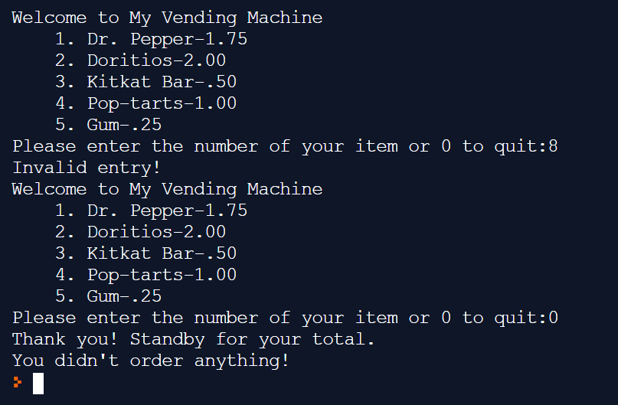

Purchases with a total greater than the user’s initial payment:

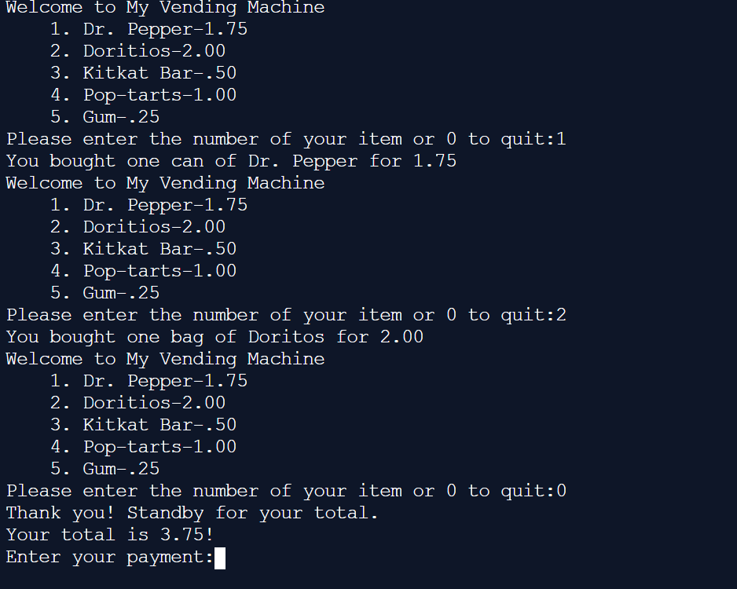

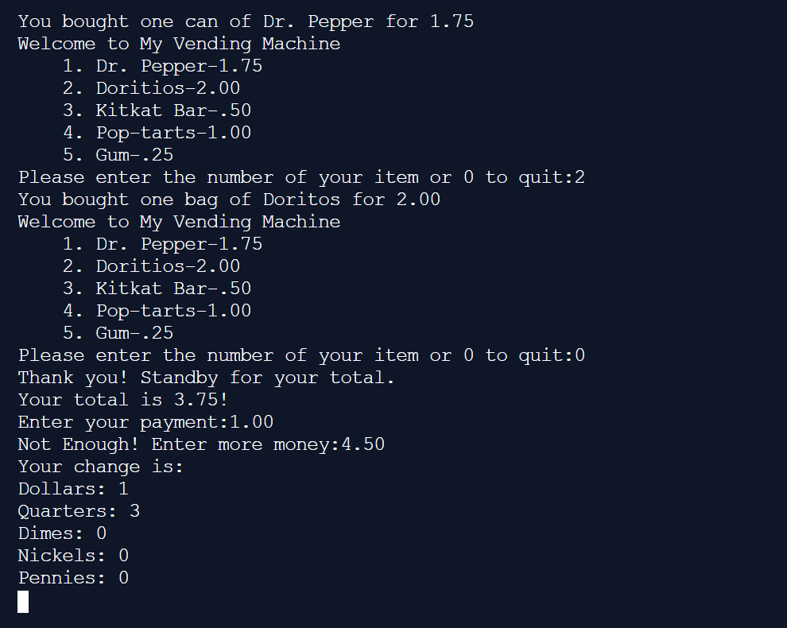

Full Mount Entered At Once:

